Static Management Program (SMP)
  - Users Guide
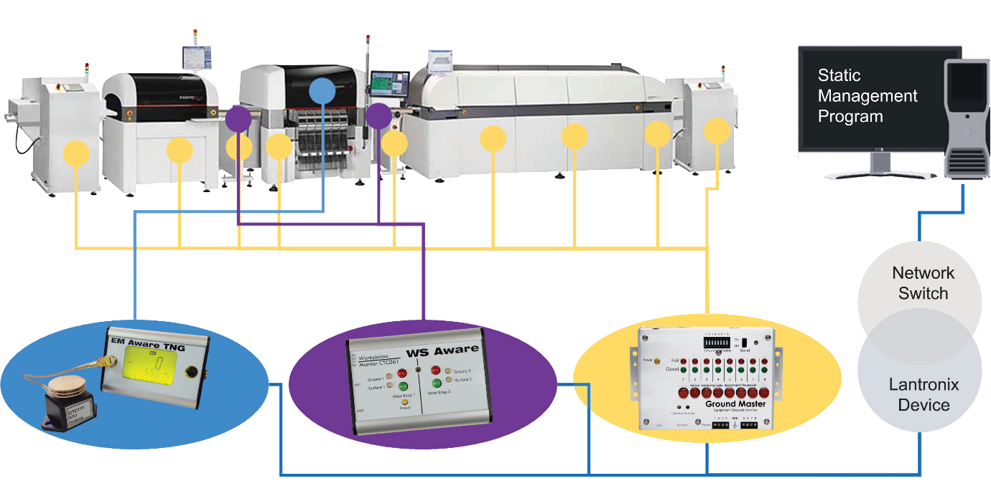

For years, electronics manufacturers have struggled to answer the question, “How do you know?” How do you know that your products are not falling victim to electrical overstress or electrostatic discharge? How do you know that damaged product does not get into the hands of your customers?

With the Static Management Program (SMP), finally, you know.

The Static Management Program offers companies an effective way to detect electrostatic discharge (ESD) events and help prevent component failures. Static control instrumentation helps businesses achieve a competitive advantage in the marketplace by reducing losses due to ESD, electromagnetic interference (EMI) and electrical overstress (EOS). The Static Management Program can assist you in identifying and addressing concerns associated with ESD, EMI and EOS issues. By helping to minimizethese concerns, your yields maylikely be improved, leading to possible cost savings and increased customer satisfaction.

The Device Monitoring System, combined with SCS's proprietary diagnostic static control instrumentation, finds and measures actual ESD events and EOS (electrical overstress) situations, instead of simply assessing the potential for such events. Our products capture, record and read data affecting your products, versus only verifying whether or not precautionary measurements are functioning properly. All of this is done in real-time, yielding your company real results.

Contents
SCS Installation 4
The SCS SMP Client 5
System Operation Monitoring 7
Building View 7
User Interface 8
Floor Level View 10
User Interface 12
Line View 14
User Interface 14
Device View 15
User Interface 18
Finding device by name 21
Invalid State Notifications 23
Alarms List 24
Alarm Information 26
Resolving Alarms 27
Handling Important Alarms 30
Entering Comments Without Handling an Alarm 30
Reviewing Alarm Handling History 31
Troubleshooting Other Problems 32
Reviewing Problem Solution Hints for Previous Problems on a Device 35
Data Analysis 36
Device History 36
Graph View 38
Marking Important System-wide Events 39
Table View 41
Faults View 43
Status View 44
History View Options 44
Exporting History Data 45
History Comparison Report 47
Faults Report 51
Summary View 53
Details View 56
Showing History Data for Fault 58
Exporting the Faults Report 59
Connecting to the SCS Static Management Program (SMP) Server 60
Walkthrough: Connecting to the Network Server 61
Walkthrough: Connecting to a Web Server 62

Installation
The Static Management Program (SMP) installation procedure is described in full detail in the SMP Installation Guide document. This document will focus on SMP Client application features. Please refer to the “SCS SMP Client Applications Installation” chapter in the SMP Installation guide for further details.
After completing the installation procedure described in the chapter “SCS SMP Client Applications Installation” in the SMP Installation Guide (with Client, Admin and Plan Editor selected for installation), the SCS folder under All Programs should look like:
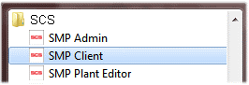
TIP
Most users will only install the SMP Device Monitoring Client since the other two applications serve for system administration and initialization
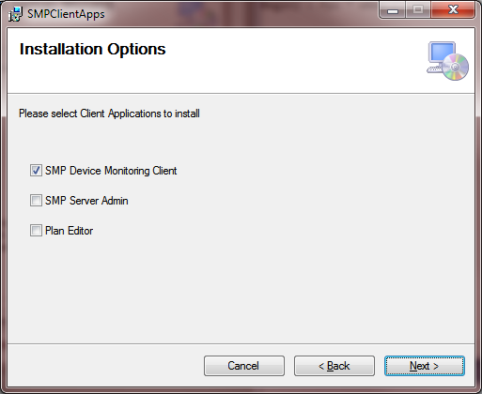

The Static Management Program (SMP) Client
The SMP Client (SMPClient.exe) is the central client application of the Static Management Program. It connects to the Static Monitoring Server over the network to provide the following services:
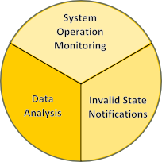
Monitoring – real time monitoring of all devices, including statuses and numerical values.
Alarms – notifications of device measurements above or below configured operational limits.
Reports – detailed fault reports with aggregation, sorting and filtering, and detailed device measurements. It is possible to export report data to Excel and text (delimited) formats.

It may be necessary to set up the connection to the SMP Server first. When the SMP Client starts for the first time it will ask for a server (if the default server is not available). This procedure is described in full detail in the chapter “Connecting to the SCS SMP Server”.
Once started, the SMP Client provides a system overview, as shown below:
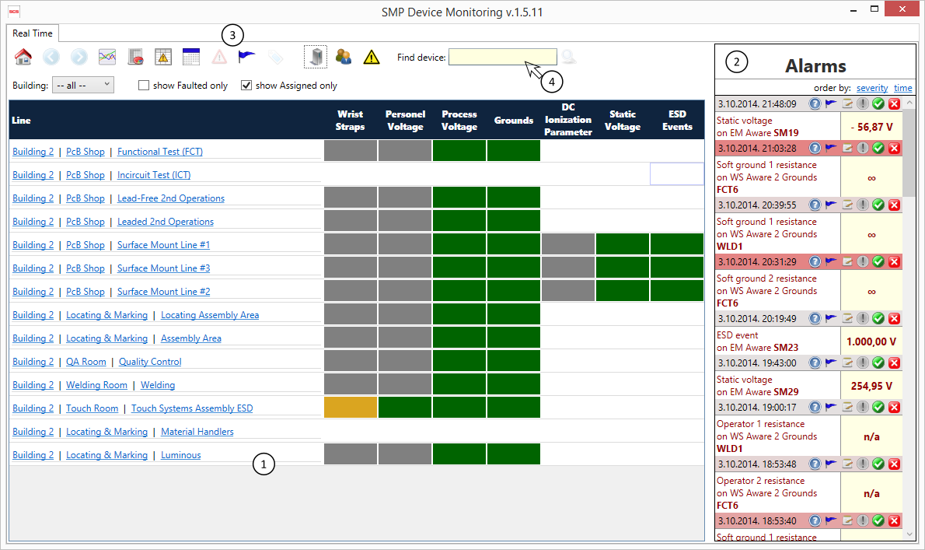
The application uses a tabbed user interface with the leftmost tab, labeled Real Time, showing views into the system operation, and is divided into three areas:
- Status View monitors the system at various levels of detail, ranging from the whole system to a single device. The status view is refreshed in real time once per second and shows “live” values.
- Alarms showing alerts about measured values outside normal operational range. Alarms are also displayed “live” as they occur. Alarms have their level of severity indicated by title bar color.
- Main Command Bar contains the main application commands:
 | Home – navigates to the view showing the entire system
 | Back – navigates to the previous status view
 | Forward – navigates to the next status view
 | History comparison – displays a history comparison of channels from one or more devices
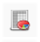 | Faults report – displays a report about system failures
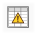 | Handled alarms report – shows a report about alarms with handling information
 | Device calibration report – shows a report about the sensor calibration schedule and also indicates (using icon color) if calibration is (over)due.
 | Inactive devices – shows a list of inactive devices
 | Troubleshoot – shows any potential system problems and suggests solutions
 | Create or View Event Tags – handles the creation and management of Event Tags (to mark important system events)
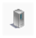 | Server – changes the Static Monitoring Server to which the application is connected
 | Login – login or change user
 | Alarms toggle – show or hide Alarms panel
- Device search is a standard auto complete search box enabling quick and easy device search by name.
Reports open in new tabs. All tabs except Real Time are closable.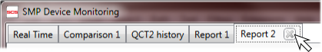

System Operation Monitoring
One of most important features of the Static Management Program (SMP) is the monitoring system’s ability to report in real-time. It is also one of three main aspects of the SMP Client application which connects to a remote server and almost instantly displays the system overview. When the application starts, the Status view shows the entire system, giving the detailed status of every line.
The status view has four possible levels of detail: building, floor, line and device. Each level shows the most relevant information, and includes several intuitive options for quickly switching between views.
Insight
The delay between physical measurement and the on-screen display is normally less than three seconds overall, but may be slightly longer depending on the network data transfer rate.

Building View
When the client application starts, it will show a view of the whole system – with the Building Level view showing all buildings, as shown in following picture: 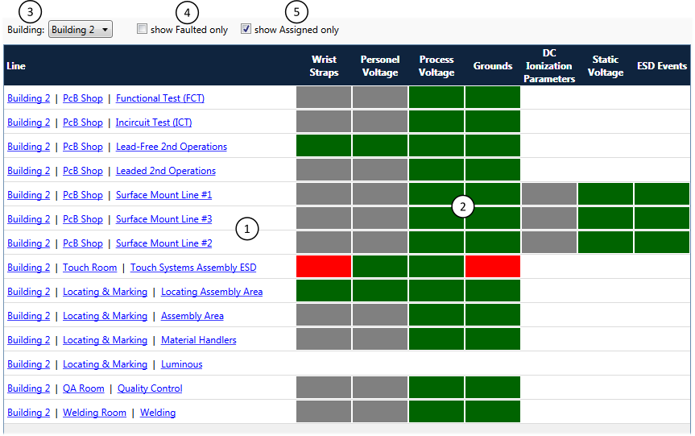
When the status view is set to Building Level (showing all buildings) it consists of:
- Navigation Links - each row contains the full line description (building name, floor name, and line name) and each of these is a “drill-down” link. Clicking on the link will switch the Status view to the appropriate level/location.
- Channel Status - shows the cumulative status of all devices within a given line by channel (measurement type). These statuses are color coded:
White: unavailable i.e. there is no device providing that type of measurement
Gray: disconnected i.e. sensors providing that type of measurement are offline
Yellow: at least one device measured value above warning limit but all values are still in
the valid range (no “red” statuses)
Red: at least one device measured a value outside of the valid range
Green: all sensors providing that type of measurement are online and within valid range
- View Selector - allows building selection via a drop down list.
- Faulted Device Filter - switches between displaying all lines and only those displaying some faulted value (red status).
- Assigned Devices Filter - switches between displaying all devices (even unassigned ones) and only assigned devices.
Devices are automatically discovered by the server, but will remain unassigned until they are explicitly associated with the system line. The Static Management Program (SMP) Client will monitor and report the operation of those devices, but they are not part of the system hierarchical organization, and therefore they can be more difficult to find. Normally, all devices should be a part of a system structure (assigned to line) but there might be some exceptions when a device is only temporarily attached for testing or becomes obsolete. Since those situations are the exceptions instead of the rule, unassigned devices are not shown by default.

User Interface
View options
The building-level status view is filtered using the Building selection drop-down menu:
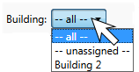
It is possible to select all (showing the whole system), while selecting unassigned will show only unassigned devices in an artificial “line” named --unassigned--. Of course, a specifically named building of your facility may also be set up as a menu item.
TIP
It is possible to quickly drill down to a specific building by clicking on the link with the building’s name in the status table.
There are two additional filtering options presented by check boxes titled “show Faulted only” and “show Assigned only” as described earlier.

Navigation
The Static Management Program (SMP) Client is designed to make system navigation simple and flexible, changing views and various drill-down options quickly and easily, usually with a single click.
Navigation Links
At the Building level, the status table shows each line with a full description, consisting of Building, Floor, and Line categories in the form of drill-down links:
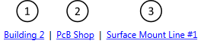
- Building Link switches (filters) the view to the selected building only
- Floor Link switches the view to the selected floor (changes to the floor-level view)
- Line Link switches the view to the selected line (changes to the line-level view)
Insight
The Floor Link will be active only if a floor is associated with a floor plan. It is not possible to navigate to a floor-level view unless there is a floor plan.
Double Click on Row
Double clicking on Row will drill down to the associated line.
Main Toolbar Navigation
The main application toolbar includes the navigation buttons: Home, Back and Forward. These buttons apply to the Status view: Home will show the whole system (all buildings) again, the Back navigation button will return to the previous view, while Forward will return to the view featured when Back was clicked.
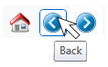

Floor Level View
The Floor Level View offers new and different insight into the operation of devices on a selected floor. Instead of the tabular form used for the Building View, the Floor is shown graphically, using a floor plan (created in SCS Plant Editor) as shown in following picture:
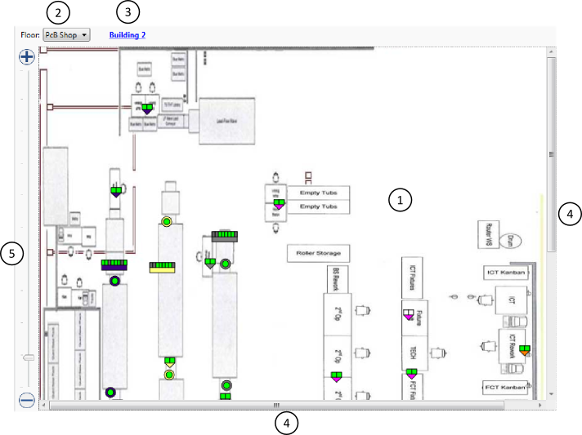
The Floor Level View consists of:
- Floor plan with device symbols, shows the status of devices which are represented by symbols on a graphical floor plan. Plans are made to scale according to the actual facility, with the status of all linked devices refreshed once per second.
- View Selector, a drop-down list allowing floor selection.
- Building Link, allowing navigation to building level.
- Scroll Bars, displayed when a floor plan is too large to fit on screen, allowing for panning.
- Zoom Slider allows screen view to zoom in and out on the floor plan.
Device symbols are the most important part of the floor-level view. These symbols present information about: real-time statuses, device name and associated line and serves as a quick drill-down links to the device view. Symbols use a standard status color coding scheme (white, gray, red, yellow and green) and also use color coding to represent the Line. All devices belonging to same line will have the same line color.

TIP
One possible organization suggestion is to associate a different Line with each Lantronix devices. In this case, all devices connected to the same Lantronix box will have the same line, and thus the same color indicator.
Distinct symbols represent distinct device types, as follows:
WS Aware Dual Workstation Monitor with two metal and soft grounds – shows statuses for two workstations in two squares and line color code in bottom triangle. Workstation rectangles are split in two diagonally to show status for voltage / resistance respectively.
WS Aware with four metal grounds – shows status of two workstations in two squares and the line color code in bottom rectangle. Workstation rectangles are split in two diagonally to show status for voltage / resistance respectively.
Ground Master Equipment Ground Monitor – shows the status of up to eight workstations in the eight topmost rectangles, and the line color code in the bottom rectangle.
EM Aware TNG ESD Event Monitor – shows the device status in the inner circle, and the line color code in the outer circle.
Ionizer Balance Controller (IBC) – shows the device status in the inner square, and the line color code in the outer square.
Fluke Thermo-Hygrometer – shows the statuses in top triangles (left for temperature, right for humidity), and the line color code in the bottom rectangle.
A tooltip containing the device name, serial number, and device type will appear when the mouse pointer hovers over the device symbol:
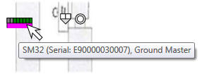

User Interface
View options
Since the floor-level status view is a graphical display, it uses the standard gestures of panning and zooming.
Panning
Panning of the visible portion of the floor plan is available only when the floor plan is too large to fit into the screen view. The two ways to pan are by:
- Using the scrollbars
- Using the mouse – holding the left mouse button pressed on the map will change the cursor to a four-way arrow indicating that panning is available. Moving the mouse while holding the left button will pan within the floor plan boundaries.
Zooming
There are two ways to use the zoom feature with the floor plan:
- Using the zoom slider – moving the slider up and down will change the zoom level continuously, while the plus and minus buttons (+ and –) on the top/bottom of the slider will change the zoom level up and down.
- Using the mouse wheel – moving the mouse wheel forward will zoom in over the current mouse location, moving the wheel backward will zoom out over the current mouse location.
Displaying Device Information and Status
Hovering the mouse over the device symbol displays a tool tip with the device name and the line name. Clicking on the symbol brings up a form showing the device’s information and status:
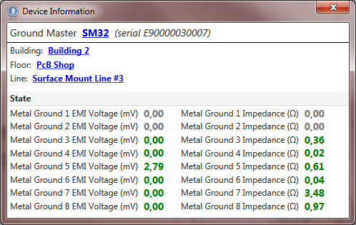

All channels (measured values) available for a device are “live” – and will change in real-time to reflect the current measurements. Also, the standard color scheme is used to display channel status.
The device Information window contains device name, type and serial number as well as standard quick navigation hyperlinks. Clicking on a navigation hyperlink will change the status view to the appropriate level (building, floor, line, device).
TIP
It is also possible to go directly to a device view from the symbol. This happens if the Shift Click combination is used: holding the Shift key while clicking on a device symbol.
Navigation
The floor Level View has quick links for changing the view to a different floor, parent building or displayed device.
Changing Floor
The Floor Selection drop down menu allows the user to change the view to a different floor:
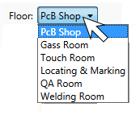
It is possible to change the view to any other floor within the system, regardless of the building, provided that there is a floor plan associated with the floor.
Navigating to the Parent Building
Clicking on the link with the building name located next to the floor selection drop down menu changes the view to the parent building of the displayed floor.
Navigating to the Device
The Device Information window described above provides a link to the device.
Main Toolbar Navigation
The Main Application toolbar has the navigation buttons (Home, Back and Forward) that apply to the Status View as described earlier:

Line View
The Line Level View also uses the tabular display format, similar to the Building Level view, but the rows correspond to the individual devices, and the status columns show specific measurement types (channels) as shown in following picture:
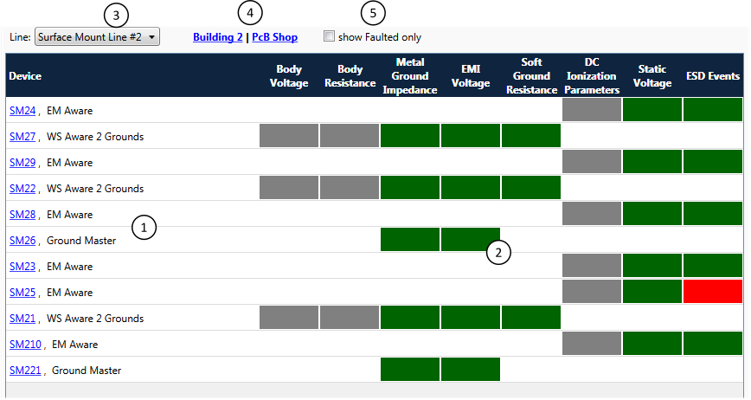
When the Status View is set to the line level (showing specific line) it consists of:
- Navigation Links - each row contains a full device description (device name and type) and each device has a “drill-down” link. Clicking on the Navigation Link will switch the Status View to the device level.
- Channel Status - shows the cumulative status of each type of measurement available, using the standard color scheme (white, gray, red, green and yellow).
- Line Selector - a drop down menu featuring line selection.
- Parent Level Links - allows navigation to parent floor and building.
- Faulted Devices Filter - switches between displaying all devices and only those that have some of measurements outside configured operational limits.

User Interface
View options
The available filtering option is presented by the check box “Show Faulted Only” as described earlier.
Navigation
The Line Level View features quick links for changing the view to a different line, parent floor, building, or a specific device.
Changing line
The Line selection drop down allows the user to change the view to a different line:
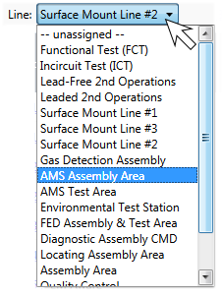
It is possible to change the view to any other line in the system, regardless of the building or floor. It is also possible to show a special, virtual line “-- unassigned --,” containing all unassigned devices.
Parent Navigation Links
Two navigation links next to the line selection drop down menu are labeled with the building and floor name, allowing the user quick navigation to the parent level.
Double Click on Row
Double clicking on Row allows the user to drill down to the associated line.
Main Toolbar Navigation
The Main Application toolbar has the navigation buttons (Home, Back and Forward) that apply to the Status View as described earlier:

Device View
The Device Level View provides the user with detailed insight into present device measurements and status. It also contains a list of the 10 most recent alarms from that device. The Device View is composed of panels. Here is an example for the Device View for the WS Aware Dual Workstation Monitor device:
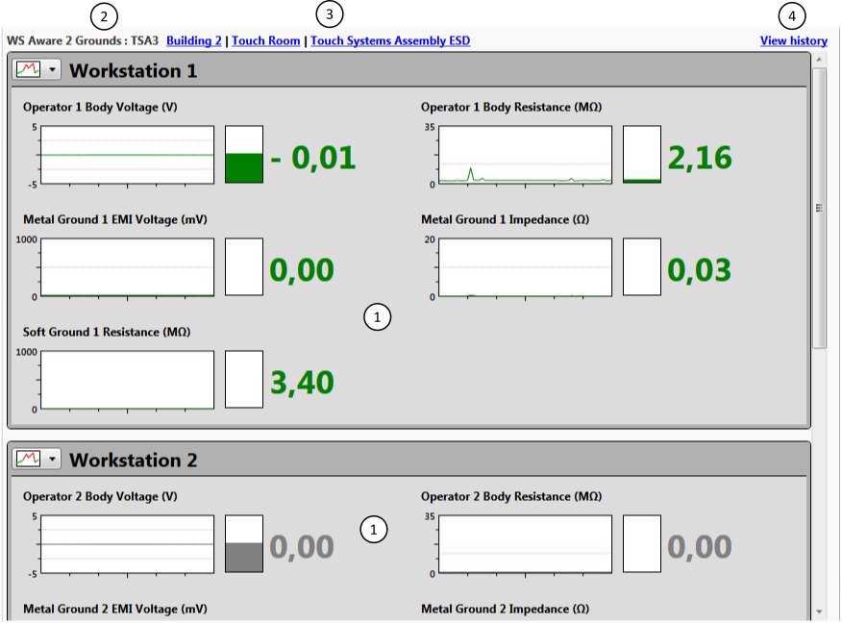
For other device types, the content will change to show relevant information, as in this example for the EM Aware TNG ESD Event Monitor:
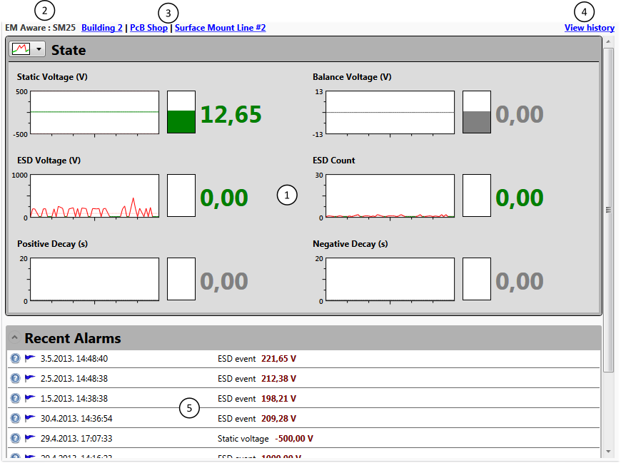
Device view consists of:
- State Panels - displays the status and numeric value for every measurement (channel). All values and status changes are shown in real-time to reflect the current situation.
- Device Info - shows the device type and name.
- Navigation Links - allows quick navigation to the parent line, floor, and building.
- View History Link - allows the display and analysis of history data (measurements collected from device).
- Recent Alarms Panel - displays a list of the 10 most recent alarms on a particular device.
Panels can show the device’s current state in detailed or compact format, or panels can be collapsed to only the title bar, as seen in this example:
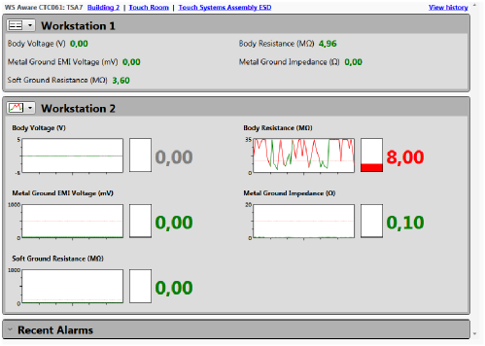

User Interface
View options
There are two view “modes” available on each State Panel. The View Mode is selected from the drop down menu located in the top left corner:
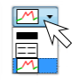
Available choices allow the user to switch between views showing detailed, compact, and no information (the panel is collapsed to title bar only). Clicking on title will cycle through the different views.

In the detailed View Mode, each type of measurement (channel) is shown as:
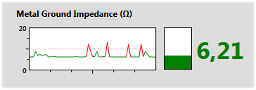
Measured value and status is shown in three convenient formats:
- Graph shows a two dimensional graph of values for the past minute (tick marks on the x-axis indicate 10 seconds each). Light pink horizontal lines indicate the configured operational limits for the device, i.e. limits of a range of valid values. The graph itself is color coded, using the standard scheme (white, gray, red, green).
- Gauge shows the current value.
- Numerical Value shows the current value.
The Detailed View Mode takes considerable space on the monitor, and in most cases doesn’t fit on a single screen. The Compact View Mode can help to eliminate the need for scrolling. In the Compact View Mode the panel contains only the description of each channel, together with the current measured value which is color coded using the standard color scheme (white, gray, red, green).
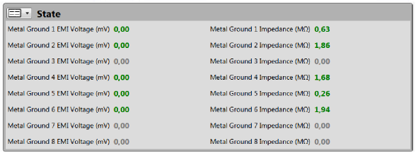
The Recent Alarms List doesn’t offer different view modes. It is only possible to collapse the list to its title bar, or to expand it to its full size.
In detailed view mode, tooltips under the mouse pointer will show the precise value. If you click on a graph in detailed view mode it will be displayed at 4 times its original size:
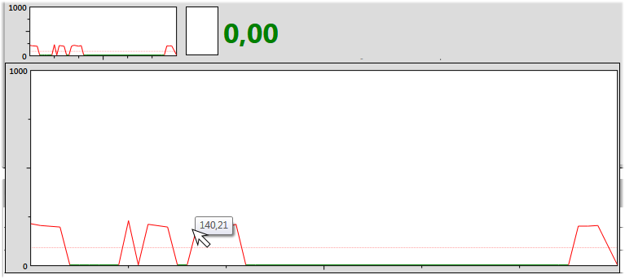
Navigation
Parent Navigation Links
The Device Level View has quick links for changing the view to the parent line, parent floor, or parent building.
Main Toolbar Navigation
The Main Application Toolbar has the Home, Back and Forward navigation buttons that apply to the Status View as described earlier:
Commands
View History
The View History link invokes the history period selection form that enables reviewing all measurements and statuses for any historical period. The device’s history will be described in full detail in the Data Analysis chapter.
Insight
It is possible to request the history for any time, but data size is limited to 1 month per report. For longer time periods, it has to be requested in one month blocks.

Troubleshooting Hints for the Recent Alarms List
The Recent Alarms list contains a blue flag button that initiates the Troubleshooting Wizard. Troubleshooting Hints will be covered in full detail in the Invalid State Notifications chapter.
Faults information for the Recent Alarms List
The Recent Alarms list contains a round blue button with question mark that shows detailed fault information for each alarm. Faults information for alarms will be covered in full detail in the Invalid State Notifications chapter.
TIP
The Static Management Program (SMP) Client has no option for monitoring two devices simultaneously. Since there is no limitation on the number of program instances that one can start, it’s easy to achieve this by starting two SMP Client instances.

Finding device by name
The main application toolbar contains the Find device auto complete search box. As you begin to type, any devices with matching names start to appear instantly. Here is example of what it looks like when the letter ‘t’ is typed in:
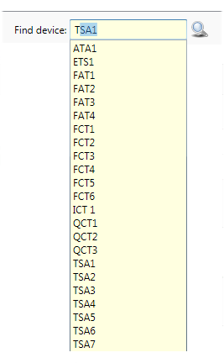

Note that all devices having the letter ‘T’ (uppercase or lowercase) in its name are shown.
Pressing the down arrow when the search box is empty will show all available devices.
Device selection is possible either by clicking on the device in the drop-down list, by pressing Enter, or clicking on the magnifying glass icon to the right of the search box.

Invalid State Notifications
The SCS Static Monitoring Server constantly tracks the status of all devices and measurements. The status and measured values are saved to the database as device history data. When any value falls out of the configured operational limits, the server will generate a fault condition for that device and measurement type (channel). In addition, the server will generate an alarm with information about the device, channel, fault value, and time. Information about the alarm and faults are also saved to the database.
The fault levels are configured in sensor firmware, and it is possible to change them using Static Management Program (SMP) Admin for every device and channel (measured value). Sensor configuration is covered in full detail in the SMP Administration Guide document.
SMP can also provide a warning about potentially dangerous values before the actual alarm level is reached. The SMP Administration Guide described the concept of warnings and how to configure warning levels. In the SMP Client warnings are treated very much like faults. While alarms are indicated by red status color, warnings use yellow or orange yellow for the status indicator.
Insight
The Fault condition may last for an extended period of time. It is also possible that a fault on the same device and channel will repeat after some time. Regardless, the server will create only one alarm corresponding to the initial fault condition (but will record all subsequent faults and warnings).
Warning will also create alarm just like fault would. This “alarm” is clearly visible as warning – it will have a yellow title bar in the list of active alarms.
Since all subsequent events (faults or warnings) become associated (attached) to the alarm created by the initial event, it is possible that a warning could evolve into a fault.
The purpose of the alarm is to capture the operator’s attention and induce a response. Alarms require “handling” by the operator, and will remain on the Alarms list until they are explicitly handled.
Insight
The server will mark any alarms older than 24 hours as Expired. This automatic alarm handling is a safeguard against overflowing the Alarm List with too many items.
The Alarm List is “live” in the same manner as everything else on the Real Time tab in the SMP Client. It is refreshed every second, and under normal circumstances every new alarm will be visible in all remote clients within 1-3 seconds of its occurrence.
TIP
It is possible to hide the Alarms list by using the Alarms toggle toolbar button. This is a user-defined setting and will be remembered by program. Even though the Alarms list is hidden, the SMP Client will continue monitoring alarms in background.

Alarms List
Active alarms are displayed in the Alarms List located on the right side of Real Time tab:
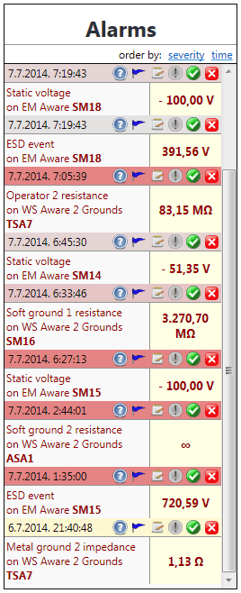
The Alarm List presents information about the alarms, including the date and time of the event, measurement type, and device type, as well as the name and faulted value that initially triggered the alarm.
The color of the title bar for each alarm in the list also indicates the severity of the alarm by using this simple color scheme: colors changes from gray to bright red as the alarm severity increases. The severity of the alarm is comprised of the combined duration and number of occurrences of the fault on the same channel. For example, if the device records too high static voltage continuously for more than 20 seconds, then that alarm will have same severity rating as another device recording 20 outbursts of static voltage lasting one second each.
Warnings use a similar color scheme – the title bar will change from pale yellow to golden as warning severity grows.
Each alarm has a set of associated commands available in the title bar:
Faults Information – shows all faults associated with this alarm. As mentioned earlier, the server will not generate new alarms for the device / channel if an active alarm has already been detected. Nevertheless, it will record all subsequent fault states and save them in the respective fault reports associated (linked) with the alarm.
Troubleshoot – starts the alarm troubleshooting wizard.
Handle alarm – offers versatile alarm handling (with comments).
Mark as Important – mark alarm as important. Important alarms will require operator comments.
Resolve Alarm – marks the alarm as resolved and removes it from the list of active alarms.
Ignore Alarm – marks the alarm as ignored and removes it from the list of active alarms.
It is possible to display the active Alarms List sorted either by descending time (this is the default) or by descending severity. There are two links labeled accordingly in the Alarms List title that change the sort order. When sorting by severity, the screen will look like this:
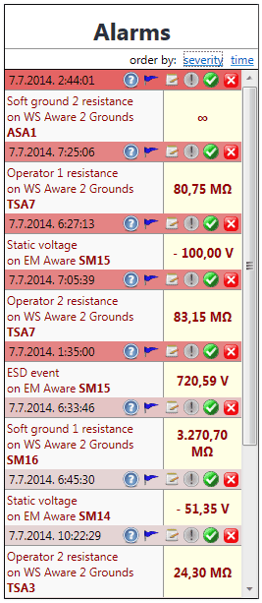
Each listed alarm is also a quick drill down link to the device – clicking on the alarm will switch the Status View to the Device Level and display the related device.

Alarm Information
Clicking on the command brings up a pop-up form showing all faults linked to the alarm:
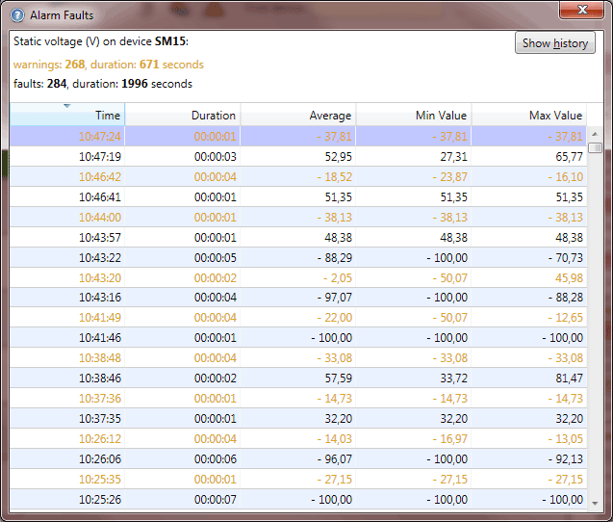
The Alarm Faults List has all relevant information including:
- measurement type (channel)
- device name
- total number of faults / warnings
- total duration of all faults / warnings
- list of individual faults with: time, duration, minimal, maximal, and average value of related measurement
The Faults List is sortable by any column – clicking on the column will change the sort order and toggle between ascending and descending order (as indicated by the arrow at the top of the column title).
Alarm information is in fact a history of all problems related to a particular device and channel.
The Alarm Information Form also features the Show History (Alt+H) button. Clicking on this button will bring up the Device History tab for the related device. The History View will contain all data from this device (not just the faulted channel) for the period of time ranging from five minutes before alarm till the present moment.

The History display and its related features will be covered in detail in the Data Analysis chapter.

Resolving Alarms
Alarms are a very important feature of the Static Monitoring Program. Their purpose is to capture the operator’s attention and indicate potentially dangerous conditions in the system. The standard operational procedure will normally require the operator to check what happened. The Static Management Program (SMP) Client provides several quick and convenient ways to review the present situation as well as history. The operator can bring up the Device View with a single click on the displayed alarm and check the current values or review the recent history.
In some cases, the operator may have to check the situation on site and work toward problem resolution. The SMP Client can help here and provide standard problem resolution hints. Clicking on the troubleshooting button will bring up Troubleshoot Problems Wizard:
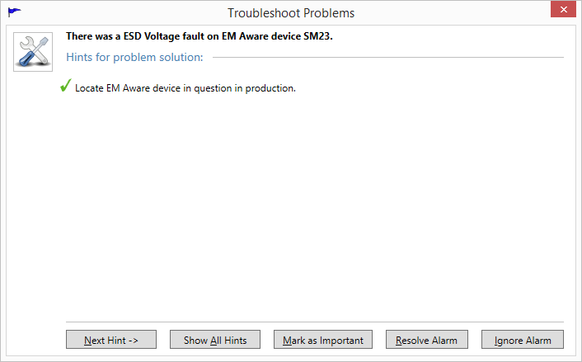
This pop-up form guides the operator toward resolving the cause of the alarm by displaying hints step-by-step (clicking on Next Hint (Alt+N) will show next available hint):
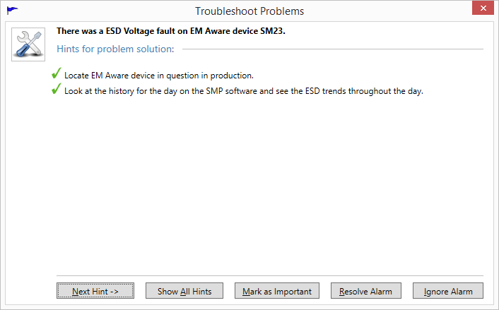
Clicking on the Show All Hints (Alt+A) link goes instantly to last available step:
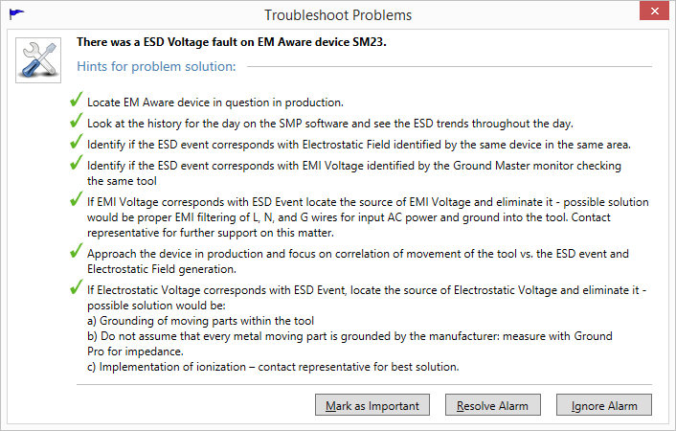
Standard operational procedure normally requires problem resolution. Ultimately, the operator in charge should always take some action. In some cases, the alarm will indicate only a glitch on the device, or it has registered a temporary event with an undeterminable cause. It is possible to ignore such alarms, but in most cases the alarms should be effectively resolved.

The Troubleshooting Wizard has Resolve Alarm (Alt+R) and Ignore Alarm (Alt+I) buttons for alarm resolution. Clicking on either of them will mark the alarm accordingly, close the wizard and remove the alarm from the recent alarms list. Please note that a Mark as Important button is also available. The purpose, implications, and functionality of this option will be detailed in the chapter Handling important alarms.
If the operator closes the wizard using the close window button, the alarm will not be handled and will remain in the recent alarms list.
It is also possible to handle alarms without help from the Troubleshooting Wizard by clicking on the Resolve orIgnore buttons.
Insight
It is possible to “secure” the Static Monitoring Server. In that case, the server will require that a user with the appropriate security clearance has logged in to the SMP Client in order to handle the alarm. If a user without the appropriate security level attempts to handle an alarm they will see the following message:
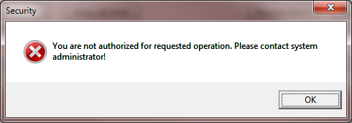
If SMP is secured then an authenticated user will have to have at least the Operator role to be able to handle alarms.
Details about server security and user rights are available in the SMP Administration Guide document.

It is also possible to enter operator comments about each alarm handling action by clicking on the button:
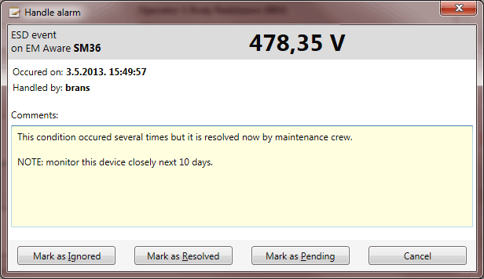

Handling Important Alarms
For certain events (alarms), the system manager or administrator has an option to give them special “importance”. When a manager marks an alarm as important by clicking on the button in the alarm toolbar, it will become “important”, and any subsequent attempt to handle it quickly (resolve or ignore without comments) will fail. When an operator tries to handle the alarm using any of the methods described above, an alarm handling form will pop up automatically, prompting the operator for comment.
Alarms marked as important will be clearly visible because the importance icon will change color as shown here:
Insight
A minimal role of Manager is required to mark an alarm as important.

Entering Comments Without Handling an Alarm
SMP provides another feature in problem handling that may help in system maintenance and analysis. It is possible to enter comments about an alarm without explicit handling. Alarm handling will always dismiss an alarm from the list of active alarms. It is often useful to have option of entering comments or notes about condition even though it’s not yet resolved.

Reviewing Alarm Handling History
The Static Management Program (SMP) Client allows review of alarm handling actions which can be filtered by various criteria. Clicking on the button on the main application toolbar brings up the criteria form:
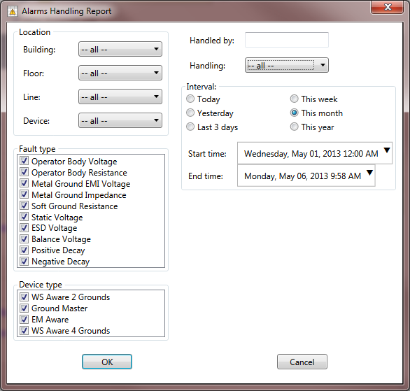
The location criteria are initially set in a context-sensitive way, meaning that if the form is invoked from the floor view, it will automatically set the filter to that floor.
Alarms Handling Report includes versatile filtering. It is possible to choose a combination of:
- location (building, floor, line, device)
- type of fault
- type of device
- person that handled alarm
- handling type (expired, ignored, resolved)
- time interval (when alarm was handled)
The Alarms handling report looks like this:
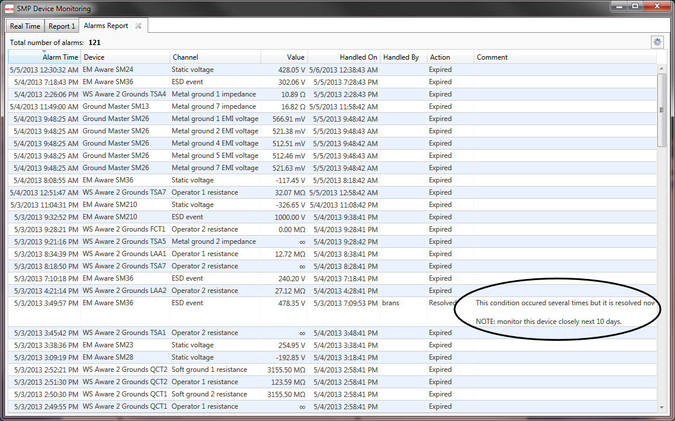
Please note the circled comment showing a handled alarm in the example above.
The data table in this report has standard features. Every column is sortable, and it is also possible to filter further by clicking on the Change Criteria button (marked with gear symbol in the title bar).

Troubleshooting Other Problems
The main toolbar on the Real Time tab also contains the Troubleshoot command button (). The purpose of this command is to show the problem solution tips for all potential problems on the current level. This command is context-sensitive, and will display only the problems related to the currently displayed system level. For example, if the Status View shows a floor, then it will show problems only on that floor. If the Status View shows the whole system, it will show all problems within the system, etc.

Clicking on Troubleshoot Problems on the main toolbar brings up the following form:
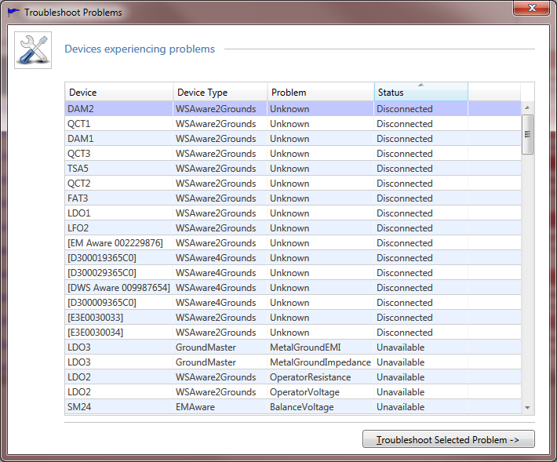
This form lists all potentially problematic devices identified by device name, device type, problem, and device status. The list itself is sortable on any column – clicking on the header will switch the sort order (toggling between ascending and descending order).
The status can be:
- Disconnected - the device is disconnected (indicated by the white status color) and the Problem is “Unknown,” since neither channel value is available.
- Unavailable - the specific measurement (channel) is not available (indicated by the gray status color)
- Faulted - the specific measurement (channel) is out of operational range (indicated by the red status color)
Double-clicking on the selected row, or selecting the row and clicking Troubleshoot Selected Problem (Alt+T) will bring up the wizard:
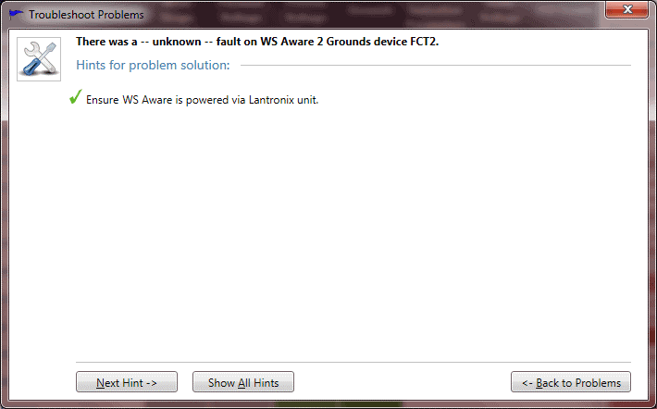
Since this problem is generally not associated with the alarm, the Troubleshooting Wizard does not include commands for alarm handling.
There is a Back to Problems (Alt+B) button available to return back to the page showing the list of all problems. The operator can use this to move back and forth between the alarms list and problem solution hints to solve many of them at once.

Reviewing Problem Solution Hints for Previous Problems on a Device
It was mentioned earlier in the System Operation Monitoring chapter that the Recent Alarms list on the Device Level status view features the Troubleshoot button for each alarm (indicated by the standard blue flag). Clicking on the Troubleshoot button will also bring up the Troubleshoot Wizard:
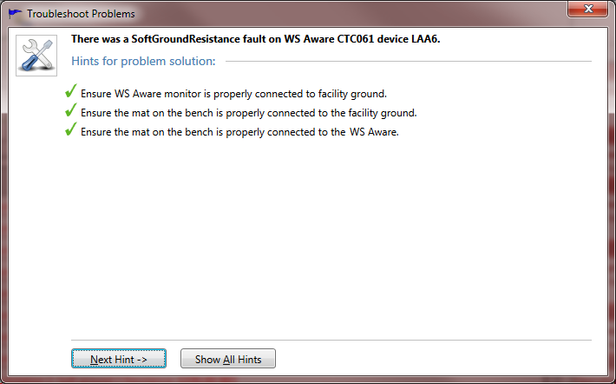
Since the recent Alarms List shows the history, most of the alarm issues will already be handled. For this reason, the problem resolution buttons are not available here. This feature is only a reminder of the standard operational procedure used to resolve active alarms. The operator should use the Alarms List and troubleshoot from there.

Data Analysis
The Static Management Program (SMP) would not be complete without versatile data analysis. The SMP Client offers detailed analysis and review of two data categories: history of all measured values, and faults history. Each data report depends on the input criteria, and is available on every view level: from the whole system, down to each individual device. Every new report is opened in a separate (closable) tab, allowing comparison and cross-referencing.
It is also possible to export data from the report in a format usable by other applications. The SMP Client supports export to Excel and delimited text files.

Device History
The Device History report provides detailed insight into the device operation for virtually any past period of time. SCS monitors measure several values and associated statuses (up to 16). The Static Monitoring Server is capable of monitoring up to 1,000 devices, with a data acquisition rate of once per second. Assuming that the average device gives only 10 measurements (value + status), the amount of data collected is quite significant: adding up to 10,000 values and 10,000 statuses per second. Since the server is capable of handling devices with even more measurements, it is obvious how large the size of the data collection can become.
For example, the server collects 1,382,400 numeric values and 1,382,400 statuses from every Ground Master Ground Equipment Monitor device every day. The cumulative data size for this single device is roughly 6.5 megabytes.
To cope with this extreme data size, the Static Monitoring Server stores collected data in a compressed binary format, resulting in a size reduction of 2 – 200 times. Data compression is also used to send report data to client applications. Even then, requesting history data for longer periods could quickly exhaust computer resources and network bandwidth. As a safeguard against this potential problem, the SMP Client gets data for larger periods in “condensed” format, represented with average values. The history report is limited to a maximum time span of 1 month. Please note that this amounts to about 2.5 million data points for every channel in the data set.
The most common way to ask for history is from the Device Level Status View on the Real Time tab (see the chapter titled System Operation Monitoring, Device View). Quick links to Device History are also available from Alarm Faults information, and from the Alarm Faults report, but they will show the history of the time period defined by a specific alarm / fault.
Clicking on the link View History on Device View will bring up the History criteria menu:
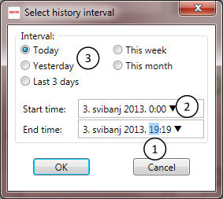
This menu is used to set the desired time range for the history data. It is not possible to set time span longer than a 24-hour period, and the time input fields will reflect that.
When any time frame is selected (as shown in (1) in the image above), rolling the mouse wheel back and forth will decrease and increase the value.
Each of the time input fields also has a pop-up calendar for the quick date selection, which is invoked by clicking on the arrow symbol (2).
There are also quick period selection links (3) for common time intervals.
Clicking OK will bring up the Device History report in a new tab:
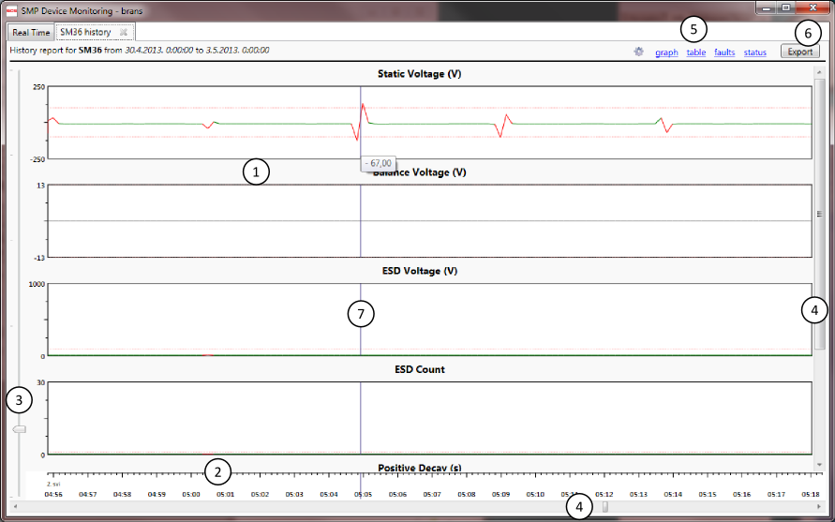
It is possible to view the History Data in the form of a graph (default) or table. It is also possible to see a list of all faults on the device within the requested history period and good / bad status percentages.

Graph View
History opens in a graph view as shown in the screen shot above with a new tab labeled “XXX History” where “XXX” stands for the name of the device. The report caption also shows the name of the device (in bold), and the history time period. Graphs use the standard status color scheme (white, gray, red, yellow, and green). The Graph View consists of:
- Channel Graphs - each measured value (channel) is shown as a separate graph. The Graph’s title shows the measurement type and unit.
- Time Ruler - indicates time.
- Zoom Slider - allows the user to zoom in and out on graphs.
- Scroll Bars - allows scrolling to channels that do not fit in the window or panning of graphs.
- Command Links - allows the user to switch between available History Views and choose View options.
- Export button – allows export to delimited text or Excel
- Visual aids – vertical blue line that follows the cursor to help correlate values of different channels, the tooltip under the cursor shows the precise value.
User interface
Graphs give the user a convenient overview of the values trend over time, but it is also possible to zoom in to finer detail and pan graphs left and right over the Time Scale. The user interface for graph navigation is exactly identical to the user interface for floor plan navigation. It is possible to zoom in using the zoom slider and pan using the horizontal scroll bar, but it is far more convenient to use the mouse. Zooming is done with the mouse wheel (rolling forward will zoom in on the current mouse location) and panning is done by clicking and dragging the graph left and right while holding the button on the mouse.
Zooming in on a graph will show its values in much finer detail:
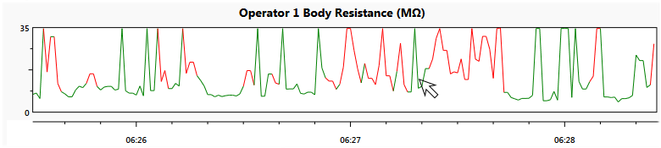
Note that the Time Ruler zooms together with graphs, reflecting the precise time.
Even though graphs give the perfect trend overview, they only offer a rough overview. To obtain precise values at time, the user should double click on the graph. This will switch to a Table View, with its focus on the precise time selected by the mouse.
Insight
When drilling down from the graph to Table View using the mouse, the resulting view will depend on the zoom factor. When the graph displays longer time periods, the Table View will do the same by using the larger sample rate.

Marking Important System-wide Events
In static monitoring it is often the case that some external condition might influence system performance: locally, or for the system as whole. SMP assists in situations like this with the Event Tags feature. This simple feature is invoked by clicking on the Create or View Event Tags command button:
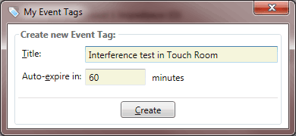
The user has the option to give a name (tag) to a system event and to define its duration. It is possible to end (close) an event tag at any time explicitly, but it is possible to predefine its duration which leaves the responsibility to close the tag to the SMP server.
Insight
If SMP is secured then event tags management is available for authorized users only, and a minimum role of User is required.
Event tags are an SMP “global” feature – once an event tag is defined by some user, every other client will see it as well (regardless of authorization level).
A subsequent click on the Event Tags button will show:
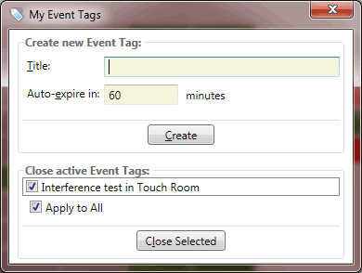
Since there is already an active tag (the one we just defined), the form will also include it in the list of active tags. The active tags list provides a convenient method for closing active tags before they reach their defined expiry time.
Created event tags will show in all history (and comparison) graphs as shown here:
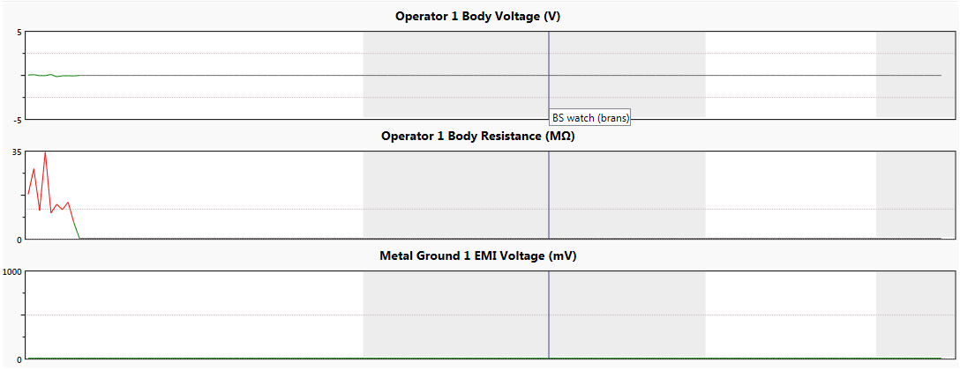
Event tags correspond to marked periods (gray areas). Right click anywhere within marked area will show tool tip with tag name (label).

Table View
The Table View of the History Data is best utilized for numerical data analysis. The Table View may also be used as a source for data export. When using the Table View, the first column displays the time, and the other columns correspond to the measured values:
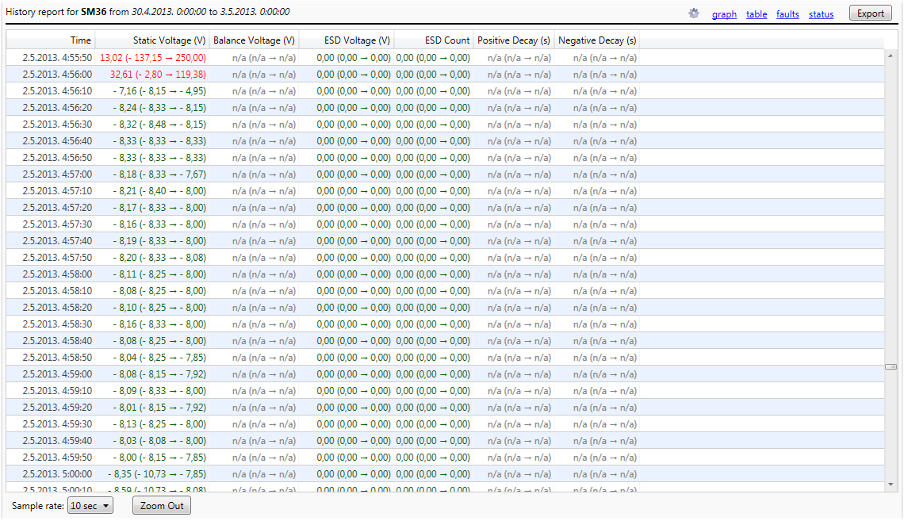
The Static Management Program (SMP) possesses a robust History Data, capable of creating extremely detailed tables. However, tables with so many rows and columns are not very user friendly. To make History Data navigation manageable and easier to use, the SMP Client uses aggregation.
The bottom row of the Table view contains a drop down menu labeled Sample Rate. The drop down menu offers the user the choice of a selection of aggregated formats (ranging from 12 hours to 10 seconds, depending on the length of the history period), or a detailed format (a sample rate of one second which is equal to the data acquisition rate).
In the aggregated view, each row represents an aggregation of values over an indicated time period. In the screen shot above, the History Data is displayed with a sample rate of 30 minutes. Each column shows the aggregation in format:
Average ( Min Max)
In the example above, aggregates are calculated over 10 values.
If the sample rate is changed to one second (details), the Table View will show the exact values instead:
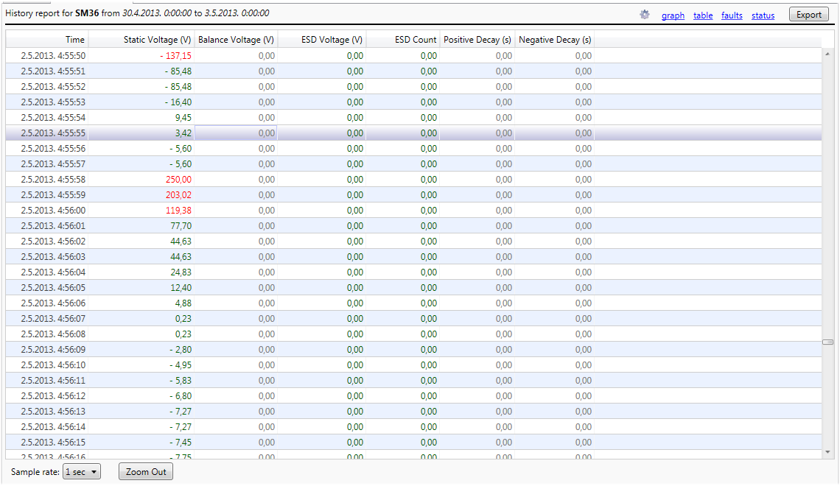
The Table View also uses the standard status color scheme (white, gray, red, yellow, and green) while displaying values.
Navigation
Changing the sample rate on the Table View is equivalent to zooming in and out on the graphical view.
The sample rate drop down menu changes the zoom feature to any level, but it is often more convenient to use the mouse. The benefit of using the mouse is that the zoomed view always stays focused on the time selected by the mouse cursor.
Double clicking on the Table row will allow the user to “zoom in” where possible, i.e. change the sample rate to the next finer level of detail.
Holding the Shift key while double clicking will “zoom out” where possible, i.e. change the sample rate to the next broadest level of detail.
Finally, the Zoom Out button is also available for changing the sample rate to the next broadest level of detail.

Faults View
The Device History report also contains a list of all recorded faults with the device within report period:
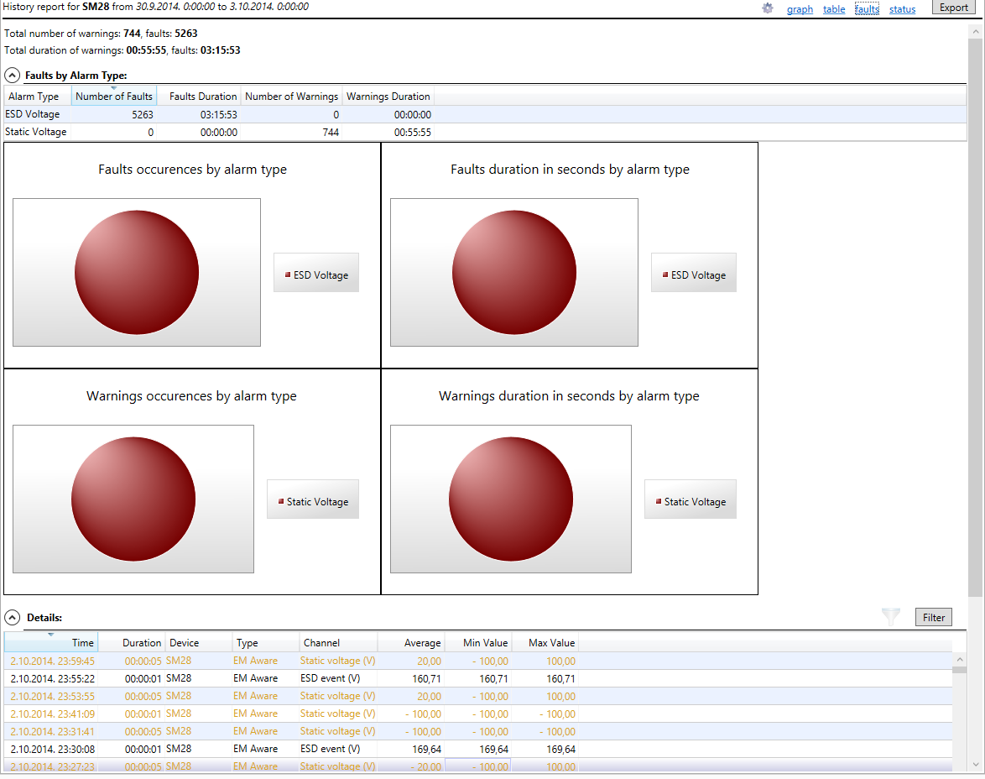
The list contains detailed information about every device fault: time, duration, channel (measurement type) with unit of measure, as well as the minimal and maximal value during fault.
Fault View also features a convenient drill down link to the Table View. Double clicking on the fault row will switch to the Table View focused on the fault period. The Sample Rate used on the resulting table view is adaptive – and may be set to record intervals, allowing the best possible view of a device’s entire fault history.
Features and functionality of faults view will be detailed later in the chapter Faults Report.

Status View
Further insight into the device operation is available on the Status View. This view provides an overview of operation in terms of good/bad/inactive status:
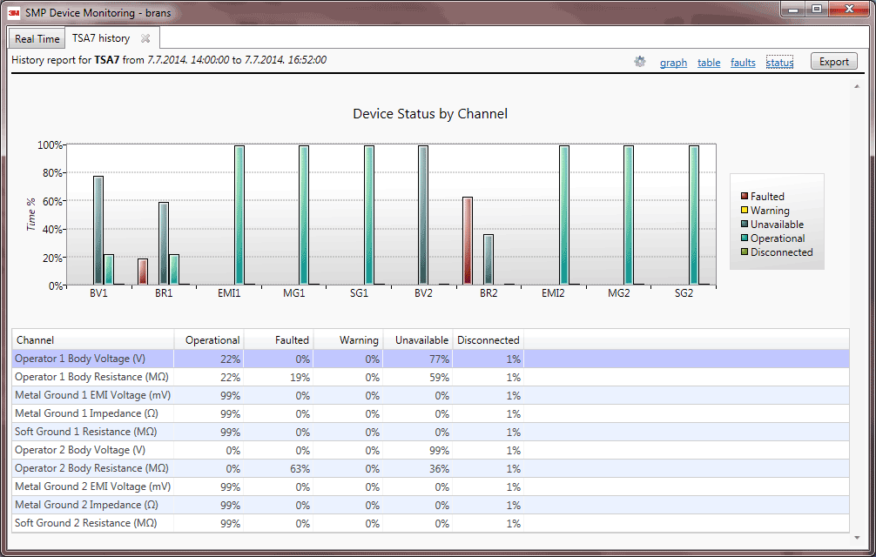
The Status View shows an overview of good / bad state for every device channel. It shows the percentages of all possible statuses (Operational, Faulted, Warning, Unavailable, or Disconnected) over the selected history period. This information is shown for every channel in both tabular and graph (bar chart) format.

History View Options
The gear symbol to the left of the command links is used to invoke the History View Options dialog:
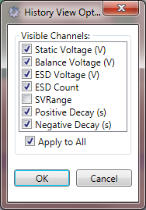

This dialog enables selection of visible channels. For example, selecting only voltage channels changes the graph view to (note that only voltage channels show):
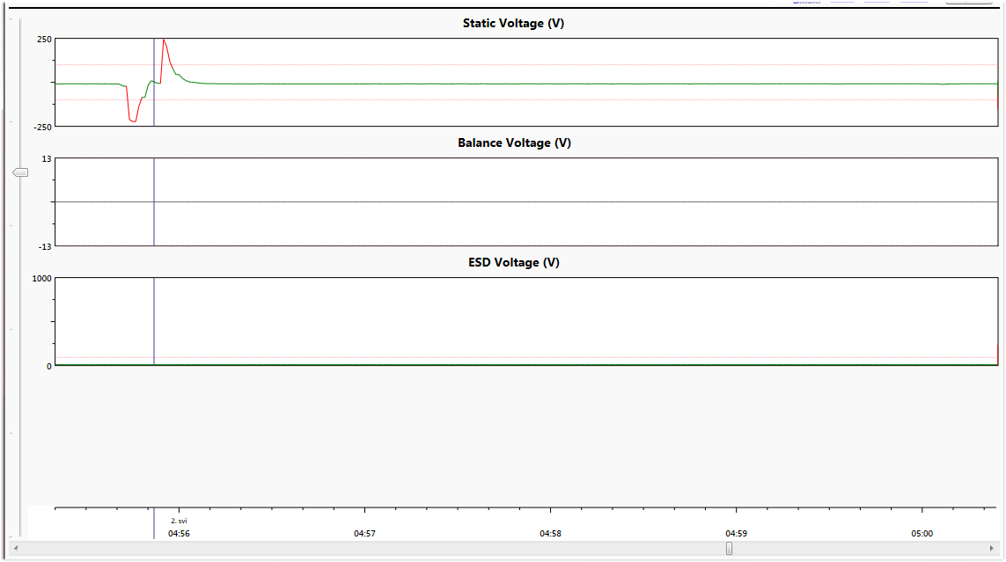
Selected view options influence all views except Faults because the Faults view has even more versatile filtering capabilities.

Exporting History Data
The Device History Report allows the user to export data in formats usable for exchange with other external applications. The traditional data exchange format every application supports is delimited text. In addition to this universal format, the SMP Client is also capable of exporting file reports to Excel.
The Export button is available on both the Table and Faults View and will bring up the Export form:
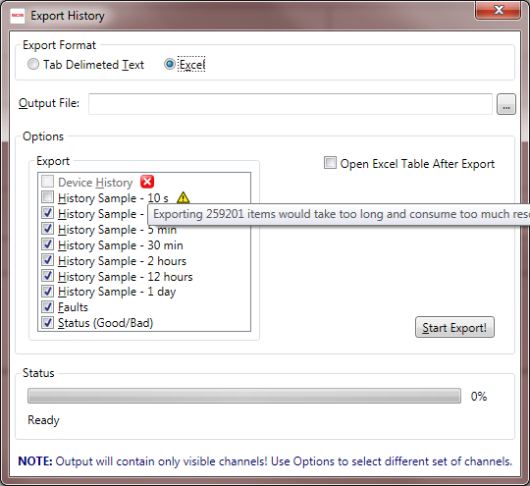
This form provides various options the user may select from, depending on the desired output format. History Reports support the export of detailed device history, as well as all history aggregations, the faults list, and Status summary.
If the output format is delimited text, then the resulting file will have field names in its first row, and will use the tab character as its field delimiter. Text export supports the export of a single report only, but all available reports can be exported to separate files one by one.
If the output format is Excel, then the resulting workbook may contain one or more available reports as separate sheets. It is also possible to automatically open an exported file when the export process is complete.
TIP
In order to open an exported Excel file, Microsoft Excel must be installed on the client’s computer. However, Excel is not required to conduct the actual act of the export itself.
Clicking on the Start Export! button initiates the export procedure, while the Status box will track the progress of the operation.
Sometimes it will not be possible to export data of a certain level of detail. In the example above, exporting of the device history data is not available (indicated with red X icon). The tooltip shows the reason for that. Sometimes exporting is possible but not recommended on a certain level of detail (indicated with yellow triangle icon) because it would result in a very large file.

History Comparison Report
In the previous chapter we have seen the capabilities and functionality offered by the device history reports. In some situations it may be beneficial to compare (correlate) channels from several devices that are located close to each other and therefore may be prone to the same conditions. SMP has a history comparison feature designed for this purpose.
Let’s look at the following example:
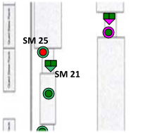
This shows an area with two devices (EM Aware SM25 and WS Aware SM21) that we want to correlate.
We can invoke History Comparison from the main application toolbar and bring up this form:
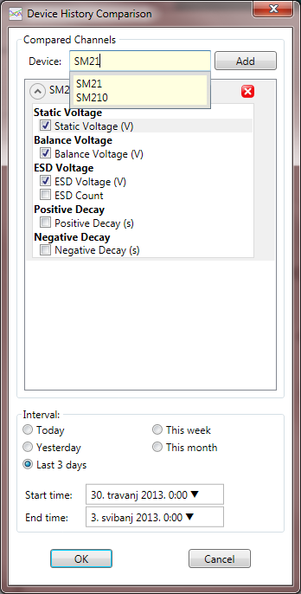

The example above already shows SM25 added, with all voltage channels selected. Also, the report period is set to the last 3 days and the device search box is only used to select SM21 (for details, see the Finding Device by Name section).
Let’s finalize by adding SM21 and selecting body voltage and resistance for both operator workstations on SM21:
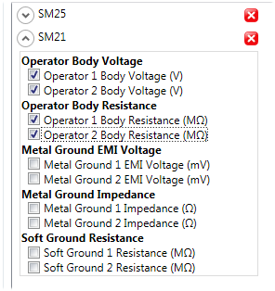
Icons with the red X symbol are used to delete a previously selected device while making a comparison choice.
The resulting report will look like this:
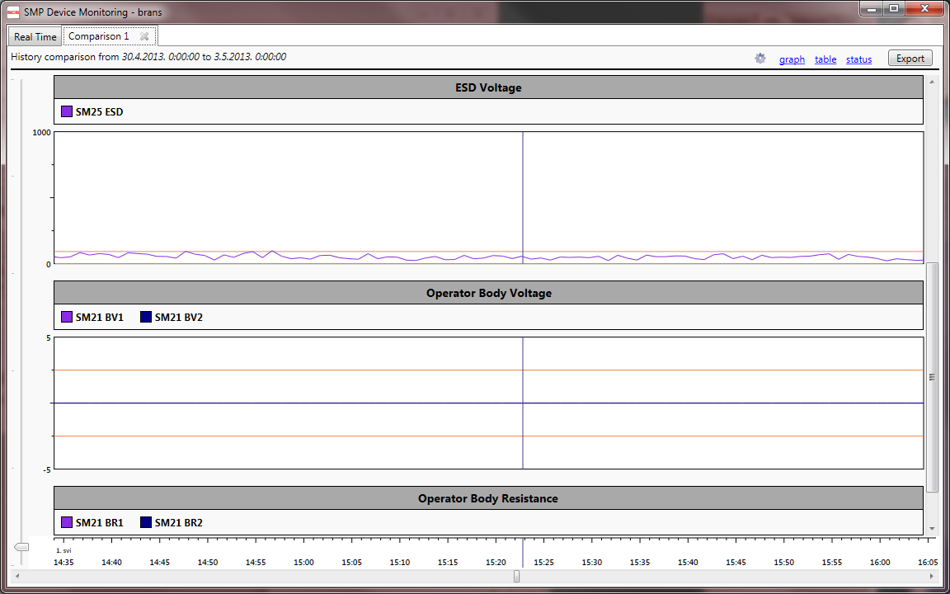
All selected channels are grouped according to similarity, i.e. compatible values are shown on a single graph as overlapping lines. Overlapping lines use different colors as indicated on the Legend above.
In the example above, the report will show the groups Static Voltage, Balance Voltage, and ESD Voltage with a single channel, and the groups Operator Body Voltage and Operator Body Resistance with two channels.
There are no physical limitations on the number of devices / channels that can fit into a comparison report, but selecting too many channels may result in something like this:
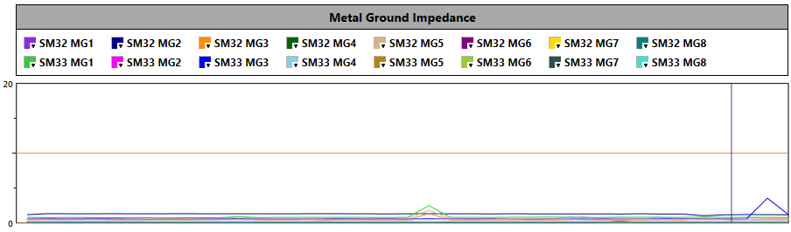
Note that we have 16 selected channels and they are hardly distinguishable from one another.
Note that legend on top of the view consists of all selected channels (color box, device name, and channel abbreviation). Color boxes are in fact buttons (indicated with an arrow in the bottom right corner). Clicking on a color will show a versatile color selector:
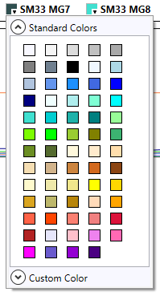
The color picker enables selection from a set of predefined colors, or even an arbitrary custom color. When a comparison graph shows more than a few channels, this may be crucial to distinguish them visually. History comparison is very much like History with respect to its features and functionality, except that Faults view is not available here. Faults reporting have much more versatile features that will be described later.

View options have a similar purpose as on the History report but look different:
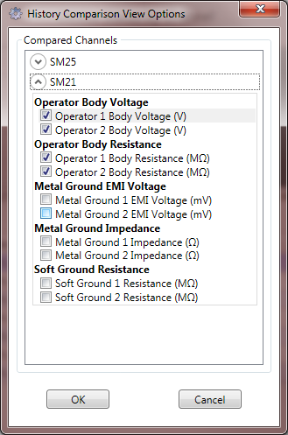
View options are used to select a different set of channels shown on the report.

Faults Report
The Faults Report provides a detailed fault analysis of any part of the system for aselected period of time. Unlike the History Report, the Faults Report is not limited in any way. It is possible to review faults over an arbitrary period of time (spanning several years) and for any area (ranging from the whole system to individual device).
The Static Monitoring Server keeps track of faults, and stores the faults data in the system database as separate entities. This is necessary to have efficient access to the Fault Data (it would be too time consuming to pull them out from history). Faults are persisted to database in a “standard” format (no compression or binary encoding) which means standard SQL queries are available. Standard SQL enables data virtualization (the client requests only a portion of data required for display), which is heavily used in the faults reporting. The important result of this technique is access to practically unlimited data size.
The Faults Report is requested from the main toolbar on the Real Time tab by clicking on the button. Like many other functions, the Static Management Program (SMP) Client Faults Report is also context-sensitive, recognizing current context and smartly adapting by restricting output only to relevant devices. When clicked on the Building Level View, it can show all faults from that building, but if clicked on the Device Level View, it will show only the faults on that device.
Clicking on the Report button will bring up Report Criteria form:
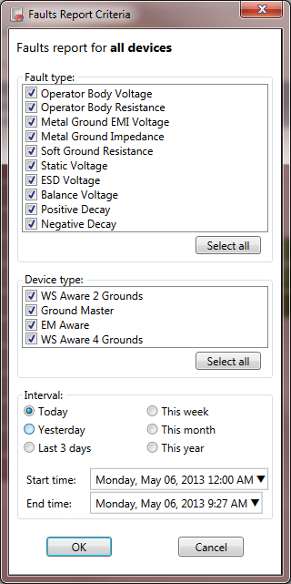

This form defines basic report criteria consisting of:
- Fault Type
- Device Type
- Time Interval (including some predefined quick choices to cover standard use cases)
The time input fields have exactly the same user interface options (mouse wheel and calendar) as described earlier for the History Report criteria form.
TIP
Once created, it is possible to filter the Faults Report further, but it will not be possible to search for data beyond the parameters defined in the Faults Report Criteria form. For example, if the device type was limited to the EM Aware TNG ESD Event Monitor only, it is not possible to include other device types in the same report later.
The fault type and device type criteria are adaptive, and depend on the context defined when the report was originally requested. Respective lists will contain only choices existing within the given context.
Clicking OK will bring up the Faults History Report in a new tab:
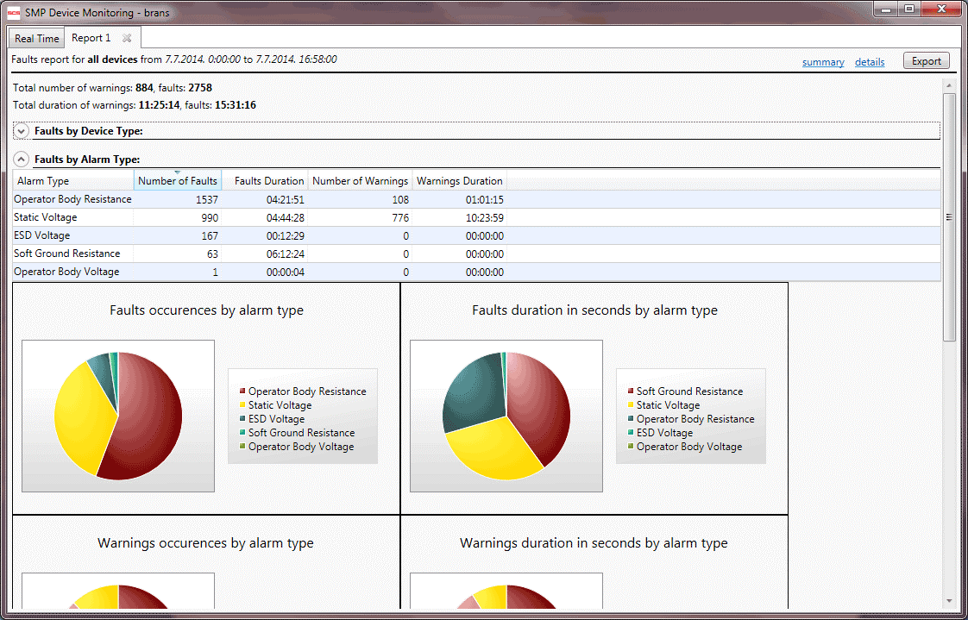
It is possible to view faults in the Summary View, showing grouped values or in the Details View, showing detailed fault information.

The Report tabs are labeled “Report nn” where nn is ordinal number increasing from one. The Report caption (in the title row) contains basic information consisting of:
- Context
- Report Time Period
- Total Number of Warnings and Faults
- Total Duration of Warnings and Faults (available only in the Summary View)

Summary View
The Summary View displays the total number and duration of warnings and faults, grouped by various criteria: device type, alarm (fault) type and individual device.
Insight
If some group in summary view is redundant (for example, the report is showing faults for a single device) then its respective group won’t be shown.
Each part of the Summary Report is laid out in a collapsible panel, and may be collapsed to the title bar only by clicking on the circled arrow button in top left corner.
Faults by Device Type
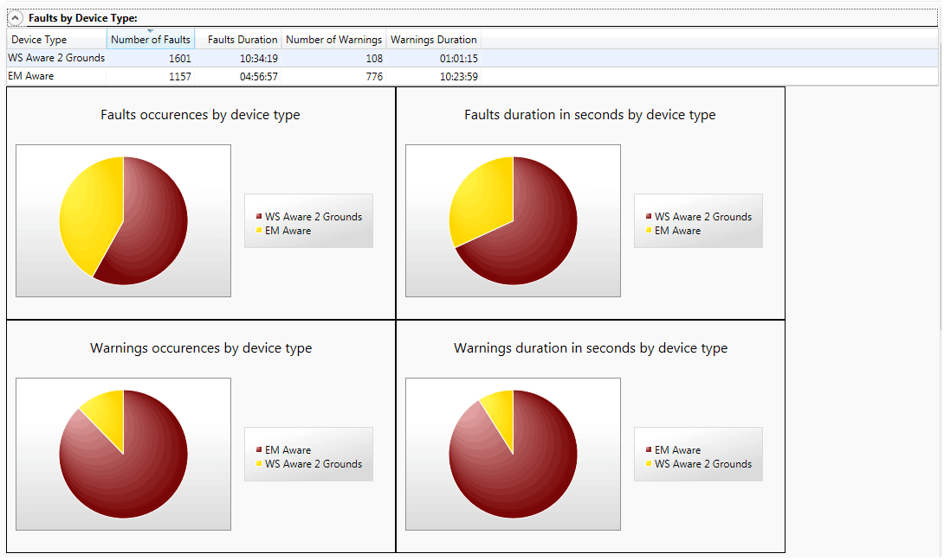
This section is capable of producing a table with sortable columns and four pie chart diagrams to show a graphic display of the number and duration of faults and warnings respectively.
The Faults by Device Type table also provides another quick drill down link. Double clicking on the table row will switch to the Details View and set the filter to the clicked device type, i.e. it will show detailed faults of selected type only.
Faults by Alarm Type
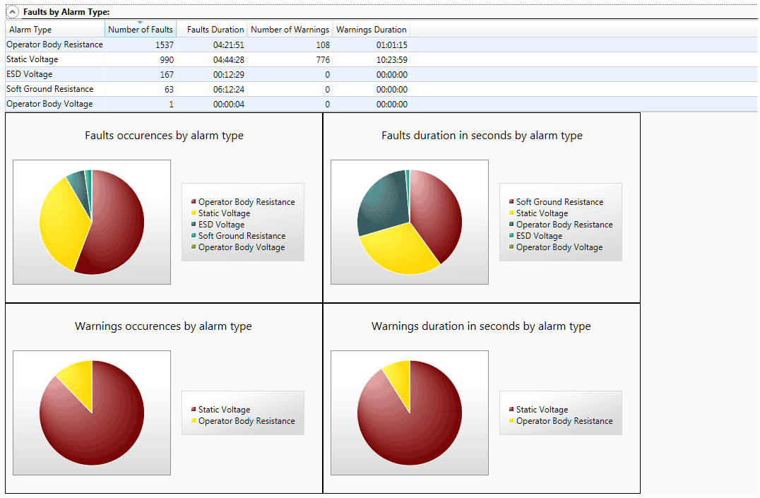
The Faults by Alarm Type section features a table with sortable columns and four pie chart diagrams to show a graphic display of the number and duration of warnings and faults respectively.
The table also provides another quick drill down link. Double clicking on the table row will switch to the details view and set the filter to the clicked alarm type, i.e. it will show detailed faults of selected type only.
Faults by Device
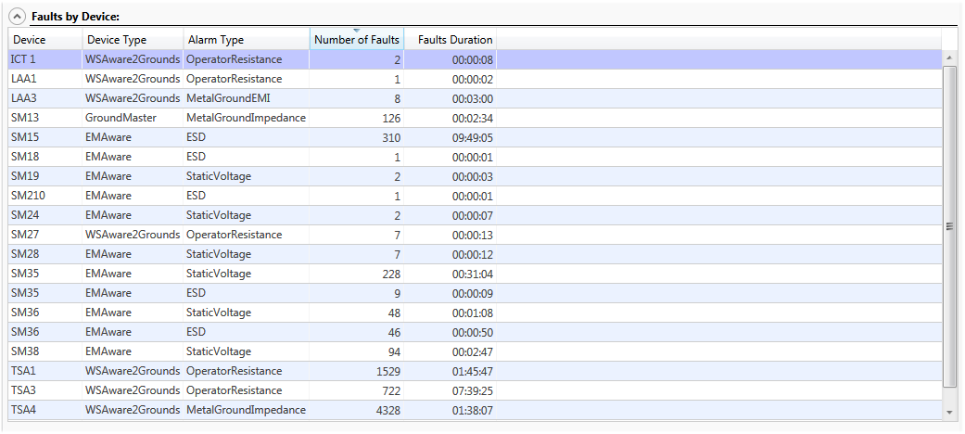
This section uses only the table to display data showing faults grouped by device and alarm type.
This table also provides another quick drill down link. Double clicking on the table row will switch to the Details View and set the filter to the clicked device and alarm type, i.e. it will show detailed faults for selected device and alarm type only.
For example, double clicking on the Static Voltage row in the Faults by Alarm Type section will switch to the Details View, showing:
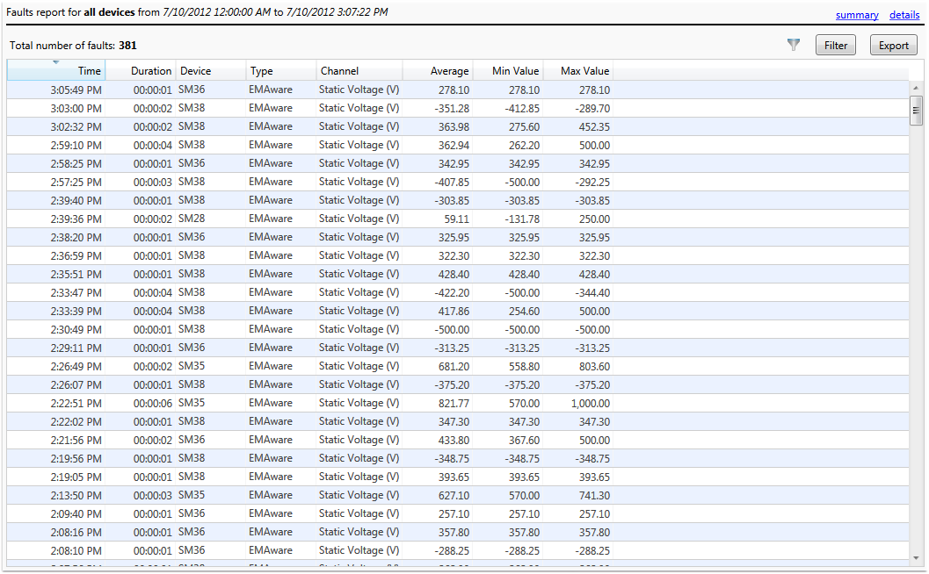
Quick links made available by double clicking rows on the Summary View tables are the only exception where general filtering capabilities are incorporated in Fault Reports (described in full detail below).

Details View
The Fault Report tab also contains familiar links (summary, details) for switching views. The Details View contains all available information about a device’s faults in tabular format:
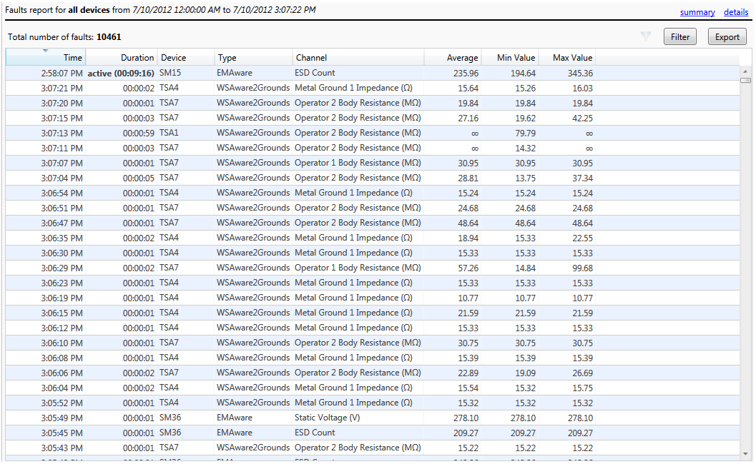
The Faults Report can potentially contain millions of items and therefore uses data virtualization to display the table. The client only fetches enough data to display the visible part of the table from server. As the table is scrolled through or sorted, a new request goes to the server, and a new portion of data arrives. The Static Management Program (SMP) Client caches some data to minimize the network traffic.
Detailed reports are usually large, which makes finding a particular piece of information quite hard. To help make this procedure quick and convenient, the SMP Client uses two techniques:
Sorting
It is possible to sort the Details table in a standard way by simply clicking on the column header. This will sort data by the selected column, or allow the user to toggle between ascending and descending order.
If a report contains any active fault (defined as a condition present at the time of report creation) these faults will be indicated with bolded duration and the word “active.” Active faults are always displayed first, regardless of the sort order.
Filtering
While sorting may help considerably in locating a particular fault, filtering offers the user an even more powerful option. The Details View contains the Filter button, and an active Filter Indicator to its left. The Filter Indicator is grayed out if the filter is not active. When the filter is active, it becomes a button that may be used to quickly clear the filter.
Clicking on the Filter button will bring up the filter criteria form. For example, this form may be used to filter out only Metal Ground Impedance faults having value larger then 70 ohms:
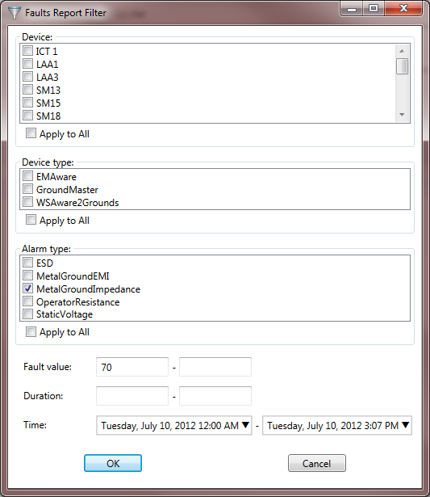
Applying this particular filter on the report sample above will yield the following results:
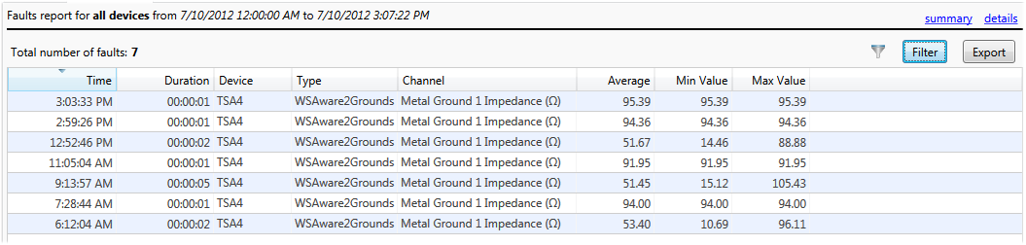
(Notice that the number of faults changed from 10,461 to only 7 that fulfill the set criteria).

Insight
Faults store three values: minimum, maximum and average over the fault period. If, in the example above, the criteria was set on the upper value limit to 80Ω (all metal ground impedance faults with value between 70 and 80 ohms), the result would contain only the third, fifth and last rows from the table above.
Notice in the fifth row above there is a recorded fault lasting for five seconds, with values ranging from 15.12 ohms to 105.43 ohms. Since faults do not store individual data values, it is impossible to determine if any particular value fell within the set value range, but it is highly likely that this was the case.
Therefore, the value range criteria may be interpreted as: “show all faults having their value range intersect the set criteria value range.”
The Filter Criteria form allows creation of reports that are a combination of:
- List of Individual Devices
- List of Device Types
- List of Alarm Types
- Value Range
- Duration Range
- Time
It is important to point out again that filter criteria cannot extend beyond the originally designated report criteria: it is only possible to further refine the existing data request.
TIP
The Device, Device type, and Alarm type criteria are displayed as lists of checkable items. These are all consider “all selected” and “none selected” in the same manner, meaning “apply to all.” Therefore, it is not necessary (and is only waste of time) to check all items in the list, though it is possible to click the Apply to All checkbox below every list.

Showing History Data for Fault
The Details View table offers yet another useful drill down feature. It is possible to quickly review all History Data from any given device during the defined period of fault by simply double clicking the corresponding fault row.
Doing this opens the History Data in a new tab (with all features described in the Device History above). The History time span may be set from five minutes before the fault occurrence to five minutes after the fault occurrence (or the first 24 hours of that period, if it is longer).
This particular feature completes the fault analysis, giving not only the precise values measured on the faulted channel, but also the values from all other sensors, and may help in determining the cause of the problem.

Exporting the Faults Report
The Faults Report allows the export of data in formats usable for exchange with other external applications. The traditional data exchange format every application supports is delimited text. In addition to this universal format, the Static Management Program (SMP) Client implements export to Excel.
There is an Export button available on the Details View which brings up the export form:
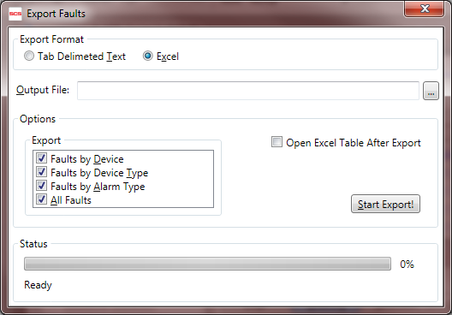
This form provides various available options depending on the desired output format. The Faults Reports support export of both faults summary and faults details.
If the output format is delimited text, then the resulting file will have field names in its first row and will use the tab character as field delimiter. Text export supports the export of a single report only, but all available reports may be exported as separate files one by one.
If the output format is Excel, then the resulting workbook may contain one or more available reports as separate sheets. It is also possible to automatically open an exported file when the export process finishes.
TIP
In order to open an exported Excel file, Microsoft Excel must be installed on the client’s computer. However, Excel is not required to conduct the actual act of the export itself.
Clicking on the Start Export! button initiates the export procedure, and the Status Box reports operation progress.

Connecting to the Static Management Program (SMP) Server
The SMP (uses distributed client/server architecture. The server is normally located on a remote computer with a physical connection to all devices. Multiple clients connect to the server using standard network protocols.
The Main toolbar on the Real Time tab in the SMP Client contains the Server button which brings up server selection form:
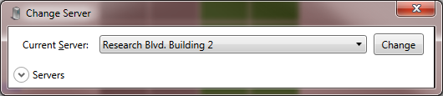
The drop down menu labeled Current Server contains a list of all available servers. To connect to a different server, simply pick the desired server from the list and press Change.
The SMP Client can store a list of (pre)defined servers, and allow the user to switch between them. A collapsible panel labeled Servers is used for managing this list:
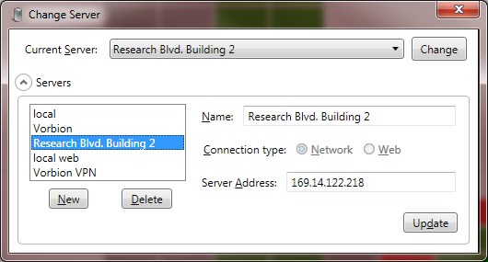
WARNING!
To use the Static Management Program (SMP) Client with a remote server, it must be defined first. By default, only the server named “local” is available initially. The local server is a server running on the local computer. Therefore, a freshly installed client will work out of the box only on the server computer. In most practical cases, the SMP Client will show the Change Server form when first initiated and require server definition.
Whenever the current server is not available, the SMP Client will show the Change Server form. This may occur when remote server is down or not accessible for some reason.

Walkthrough: Connecting to the Network Server
The SMP supports both the network and web connections between the server and clients. The network connection uses faster binary protocol, and will be used in most practical situations. It is also called the Intranet Connection because it normally requires intranet (LAN, VPN, etc.) connectivity between the client and server computer.
TIP
To establish an intranet connection to the server, please contact the network administrator to provide details such as the server network address, VPN configuration, network configuration, credentials, etc.

Walkthrough: Connecting to a Web Server
The SMP also supports web (or Internet) connections. This connection is established using the standard internet protocol and is generally slower than the network connection. The SMP also supports faster binary internet protocol, but it can often be blocked by firewalls.
Internet connections to the server are generally slower and less secure, but enable viewing the system condition even from outside of the company network.
TIP
To establish an internet connection to the server, please contact the network administrator to provide details such as server web address, port and site, credentials, etc.
The Internet server address is the standard web address, such as www.company.com/static and requires standard web address parameters.
Using the Vorbion simulated system in Zagreb provides a good example of how the simple process of defining and connecting to the internet server works.
- Expand Servers in Change Server form and click on New.
- Select Web for Connection type
- Enter Vorbion.com in Name field
- Enter www.vorbion.com in Server Address field
- Enter SMPWeb under Web Site field
- Check Use binary format box
The filled form will look like this:
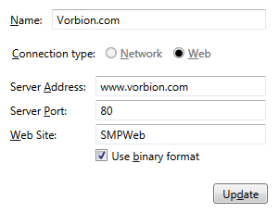
Server Port was already set to 80 which is the default web server port. Unless the web server is using some nonstandard port, it should be left at 80 (or blank). If the firewall on the client machine blocks the binary internet transfer, uncheck binary format box.
As in the previous example, clicking on Update will save this server. To switch to the Vorbion server, select it in the Current Server drop down menu and press Change.

Contact Us
Main Address: 926 JR Industrial Drive, Sanford, NC 27332
Support Number: (919) 718-0000
Support Email: Service@StaticControl.com

Limited Warranty & F.O.B. Point

Limited Warranty
SCS expressly warrants that for a period of one (1) year from the date of purchase, SCS products will be free of defects in material (parts) and workmanship (labor). Within the warranty period, a unit will be tested, repaired or replaced at SCS’s option, free of charge. Call our Customer Service Department at 919-718-0000 (Sanford, NC) for a Return Material Authorization (RMA) and proper shipping instructions and address. Please include a copy of your original packing slip, invoice, or other proof of date of purchase. Any unit under warranty should be shipped prepaid to the SCS factory. Warranty replacements will take approximately two weeks. If your unit is out of warranty, call our Customer Service Department at 919-718-0000 (Sanford, NC) for a Return Material Authorization (RMA) and proper shipping instructions and address. SCS will quote repair charges necessary to bring your unit up to factory standards.

Warranty Exclusions
THE FOREGOING EXPRESS WARRANTY IS MADE IN LIEU OF ALL OTHER PRODUCT WARRANTIES, EXPRESSED AND IMPLIED, INCLUDING MERCHANTABILITY AND FITNESS FOR A PARTICULAR PURPOSE WHICH ARE SPECIFICALLY DISCLAIMED. The express warranty will not apply to defects or damage due to accidents, neglect, misuse, alterations, operator error, or failure to properly maintain, clean or repair products.

Limit of Liability
Electronic ionizers use high voltage corona discharge and should not be used in or near flammable or explosive environments. In no event will SCS or any seller be responsible or liable for any injury, loss or damage, direct or consequential, arising out of the use of or the inability to use the product. Before using, users shall determine the suitability of the product for their intended use, and users assume all risk and liability whatsoever in connection therewith.

F.O.B. Point
Unless embodied in a written agreement signed by authorized officers of Desco Industries, Inc., the F.O.B. point for all products purchased from SCS will be the F.O.B. factory.

OUT OF WARRANTY REPAIRS
Field repair or unauthorized tampering of SCS brand products is not recommended and will nullify any and all warranties provided by DII. All SCS items to be repaired must be returned to the location referenced by DII. SCS will quote repair cost upon receipt and inspection of product. Repaired product will include a 30 day warranty specific to repair work performed and parts used. A Return Merchandise Authorization number (RMA#) must be obtained from SCS for out of warranty repairs. A copy of the RMA must accompany the shipment. The RMA number must appear on the outside of returned cartons, and SCS has the right to refuse all return shipments which do not bear the RMA number or which are shipped freight collect. Customer is responsible for all freight and transportation charges.

SCS expressly warrants that for a period of 30 days from the date or repair or calibration, SCS repaired or calibrated products will be free of defects in material (parts) and workmanship (labor). Within this limited warranty period, a unit will be tested, repaired or replaced at SCS’s option, free of charge. E-mail our Customer Service Department at Service@StaticControl.com, for a Return Material Authorization (RMA) and proper shipping instructions and address. Please include a copy of your original packing slip, invoice, or other proof of date of repair or calibration. Any unit should be shipped prepaid to the SCS factory.

